**Getting started with RStudio and Installing packages**

**Objectives of Exercise:**

After completing this lab, you will be able to:

* Load the datasets
* Install libraries

**Step 1** - Click the plus symbol on the top left and click R Script.

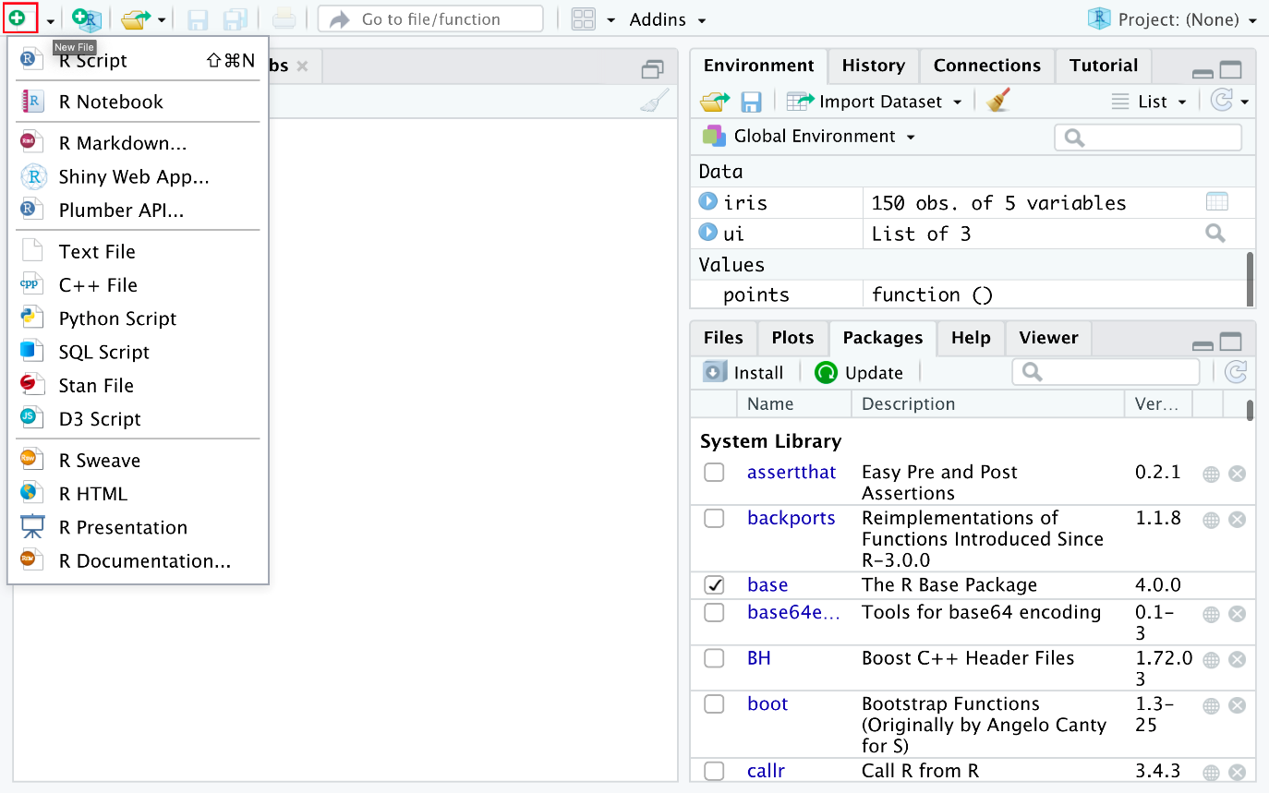

An untitled R Script panel opens. It would look like this.

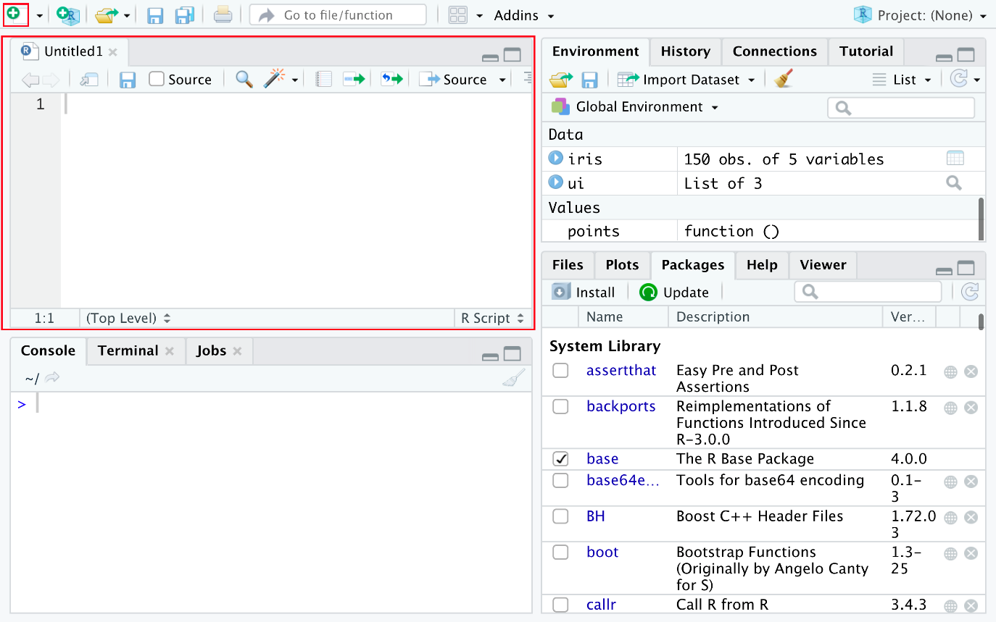

**Step 2** - Now you load the iris dataset. Enter the following lines into the editor window that appears. Then select all the text, and click Run just above the editor window.

1. 1
2. 2
3. 3
4. library (datasets)
5. data(iris)
6. View(iris)

Copied!

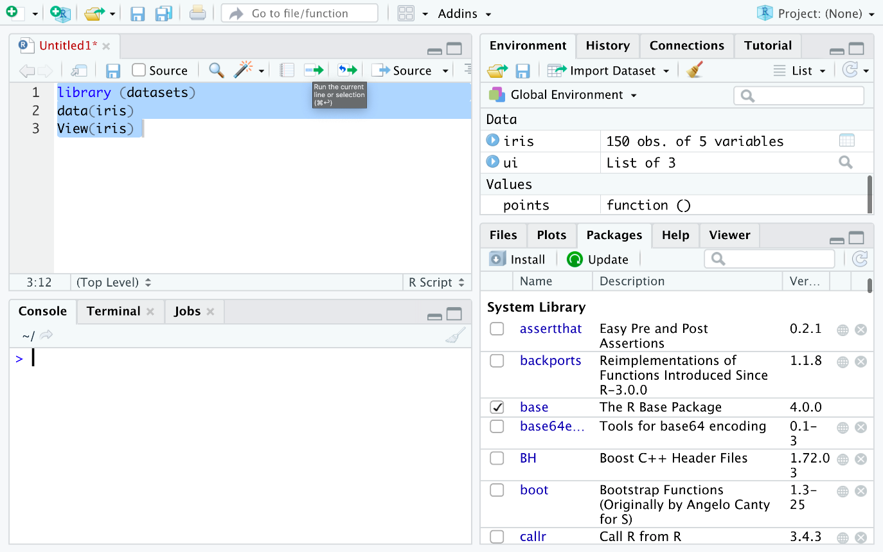

**Step 3** - You are taken to the data view tab to inspect your dataset. The dataset contains five columns and the first four are floating point type while the last column is a label of data type string which contains the category value. You can see there are total 150 entries of which you can see the first 7.

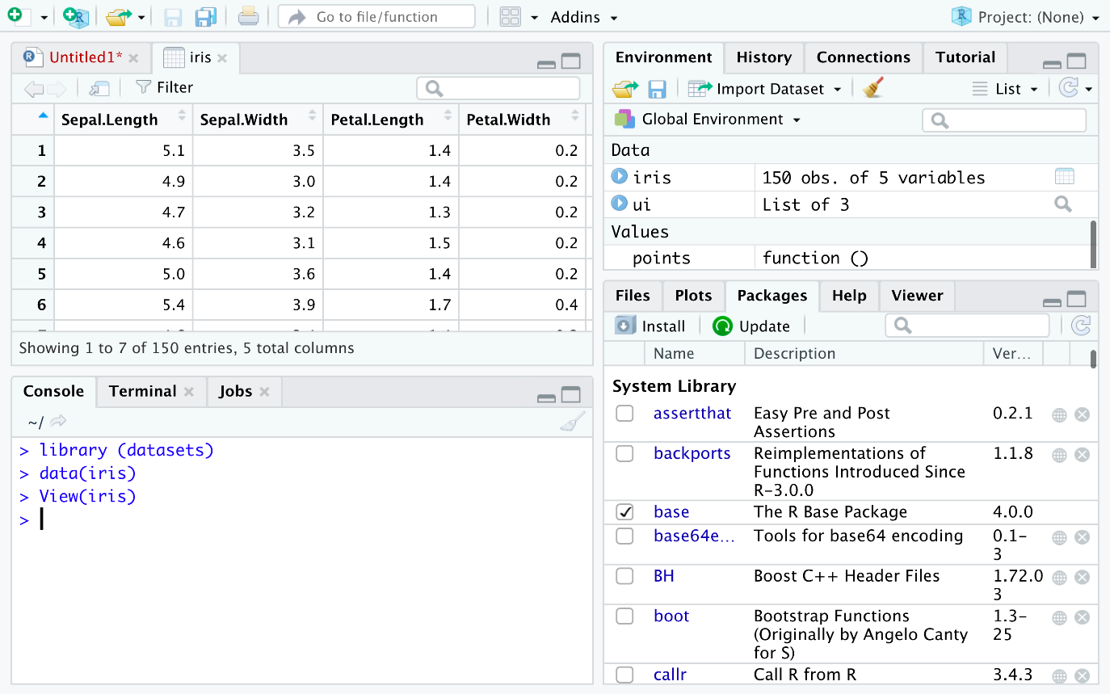

**Step 4** - Now you can find the different species present in the data set. Enter the following command in the editor window and click Run.

1. 1
2. unique(iris$Species)

Copied!

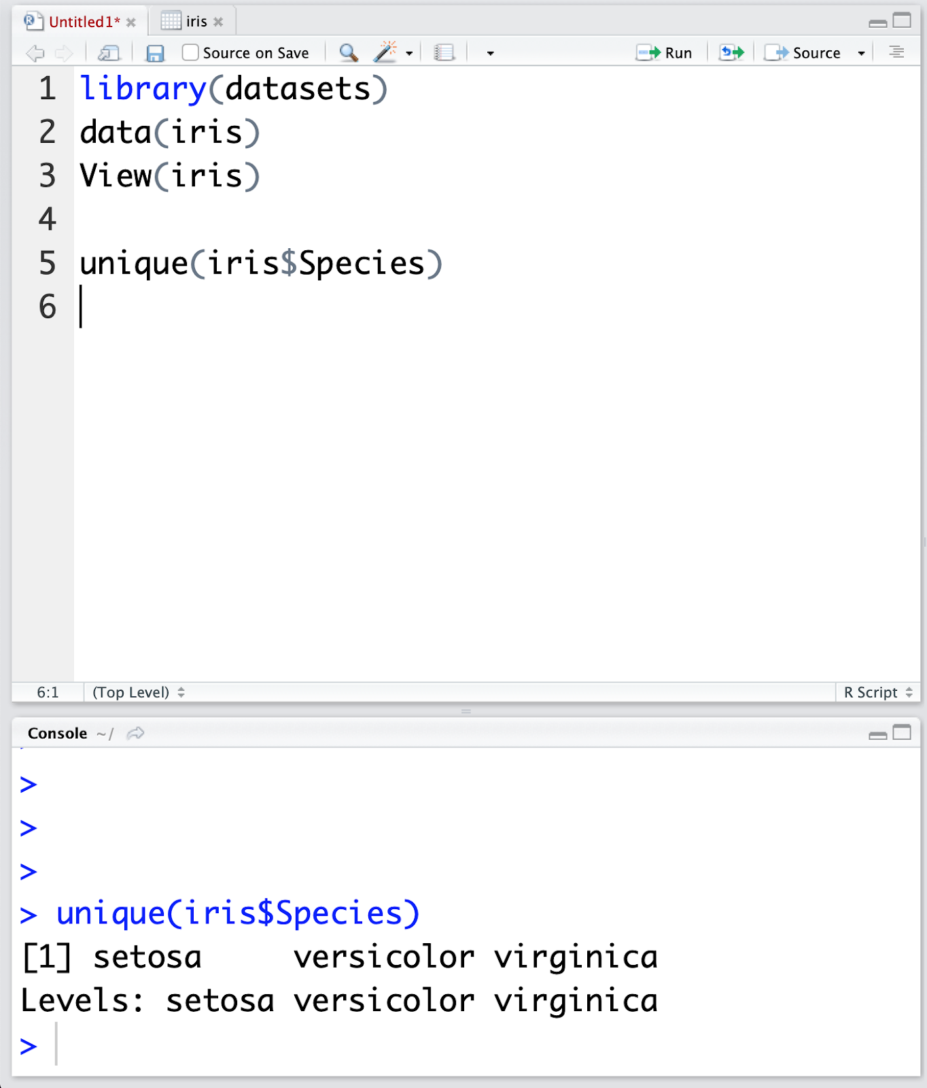

In the Console window at the bottom you can see the result of the executed command and know that there are only three different species present in the data set.

**Step 5** - Next you will look into the data set in more detail. Open a Console.

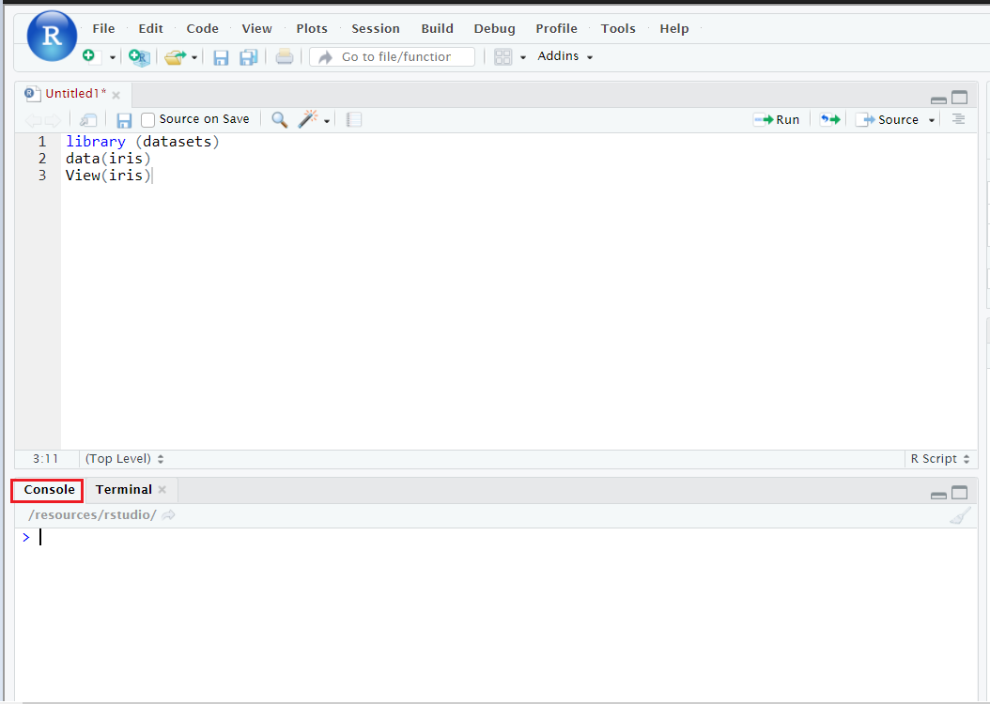

**Step 6** - Run the following command in the console.

1. 1
2. install.packages("GGally", repos = "https://cran.r-project.org", type = "source")

Copied!

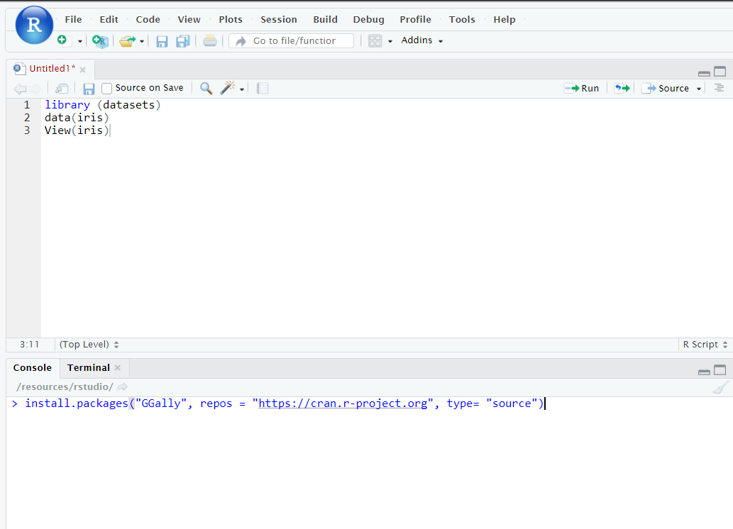

**Step 7** - Click *Enter* to install the packages.

This concludes the lab; I hope you enjoyed it!

**Author(s)**

**Romeo**

**Other Contributor(s)**

**Lavanya**

**Change log**

| **Date** | **Version** | **Changed by** | **Change Description** |
| --- | --- | --- | --- |
| 2023-07-09 | 3.0 | Anita Verma | Changed to RStudio lab |
| 2021-13-01 | 2.4 | Malika Singla | Update the installation for R packages |
| 2020-12-10 | 2.3 | Aije | Moved plot steps to a new lab |
| 2020-12-10 | 2.2 | Malika Singla | Update the installation for R packages |
| 2020-12-07 | 2.1 | Aije | Changed instructions to use Skills Network Lab |
| 2020-08-25 | 2.0 | Lavanya | Migrated Lab to Markdown and added to course repo in GitLab |
|  |  |  |  |

**IBM Corporation 2020. All rights reserved.**